File Handling in Python

File Handling allows us to store data permanently on storage devices (like a hard disk) using files.
It enables programs to create, read, write, update, and delete information beyond the scope of program execution.

Why File Handling?
- Variables store data temporarily in RAM (lost after the program ends).
- Files store data permanently for future use.
- Real-life uses:
- Storing student records
- Saving game scores
- Writing logs for debugging
- Reading/writing configurations

What is a File?
A file is a permanent storage unit that stores data in the form of text, numbers, images, audio, or video.
Unlike variables (temporary storage in RAM), files retain data even after the program ends.

Types of Files
- Text Files (.txt)
- Stores character data in human-readable format.
- Example: notes.txt
- We can open it using Notepad, VS Code, etc.
- Binary Files (.bin, .jpg, .mp4)
- Stores non-text data like images, videos, audio, etc.
- Example: photo.jpg, song.mp3
- Data is not human-readable.

Opening a File

Before performing any operation (like read/write) on a file, we must open it.
In Python, we use the built-in function:

f = open("filename", "mode")

- filename ----name of the file (with extension).
- mode ----purpose of opening the file.
Mode | Description
r | Read (text, default): open for reading
w | Write (text): open for writing, truncating file or creating new
a | Append (text): open for writing at end, creating new if needed
x | Create (text): create new file, error if exists
r+ | Read and write (text): open for both, file must exist
w+ | Write and read (text): open for read/write, truncates or creates new
a+ | Append and read (text): open for read/write, at end, creates if needed
x+ | Create and read/write (text): create new, error if exists
rb | Read (binary): open in binary mode for reading
wb | Write (binary): open in binary mode for writing, truncating or create
ab | Append (binary): open in binary mode for writing at end
xb | Create (binary): create new file in binary, error if exists
rb+ | Read and write (binary): open for reading/writing in binary, must exist
wb+ | Write and read (binary): open for reading/writing in binary, truncates or creates
ab+ | Append and read (binary): open at end for read/write in binary, creates if needed
xb+ | Create and read/write (binary): create new in binary, error if exists

Note:
All the above modes are applicable for text files. If the above modes suffixed with 'b' then these
represents for binary files.

Eg:: rb,wb,ab,r+b,w+b,a+b,xb

f = open("abc.txt","w")

Closing a File:

After completing our operations on the file,it is highly recommended to close the file. For this we have to use close() function.

f.close()
Various properties of File Object:

Once we opend a file and we got file object,we can get various details related to that file by using its properties.
name Name of opened file
mode Mode in which the file is opened
closed Returns boolean value indicates that file is closed or not
readable() Retruns boolean value indicates that whether file is readable or not
writable() Returns boolean value indicates that whether file is writable or not.

Eg::
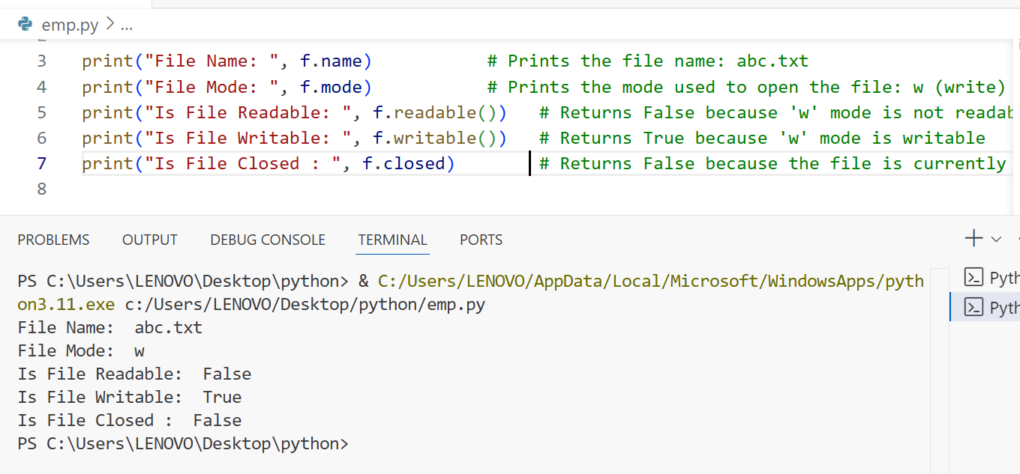

f.close()
print("Is File Closed : ", f.closed)

Writing Data to Text Files

Using write(str)
- The write() method writes a string to the text file. It does not add a newline automatically—add \n manually if lines are required.
Eg::
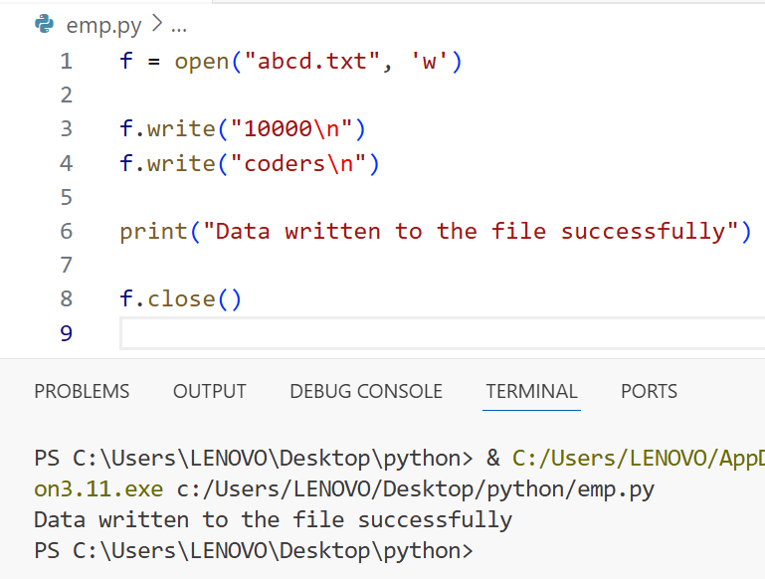

Note: Every time the program runs with 'w' mode, existing content in abcd.txt is erased and replaced with new content

Using writelines(list_of_lines)
- The writelines() method writes a list of strings to the file. It does not add newlines—each list item should end with \n if on separate lines.
Ex::
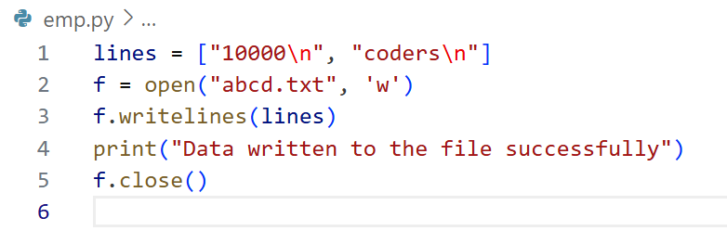
Output is the same as the previous example.

Overwriting Note
- When a file is opened in write mode ('w'), it is overwritten every run. Any previous data is lost and replaced by the new content written by the program.
- Use 'a' mode if only appending data and want to retain previous content.
Reading Character Data from text files:
We can read character data from text file by using the following read methods.
- read() To read total data from the file
- read(n) To read 'n' characters from the file
- readline() To read only one line
- readlines()To read all lines into a list

E.g. : To read total data from the file

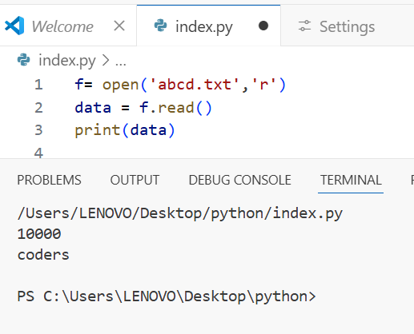

Eg 2: To read only first 10 characters:
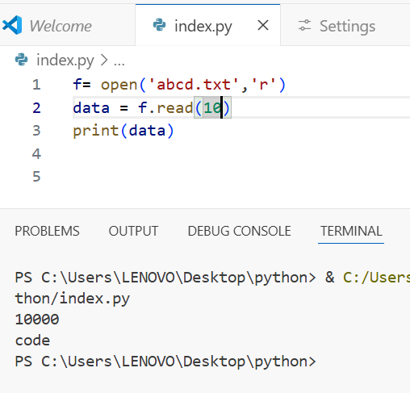

Eg 3: To read data line by line
To read data line by line in file handling using Python, you typically open the file in read mode and then iterate through the file object, which reads one line at a time. Here's a simple example:

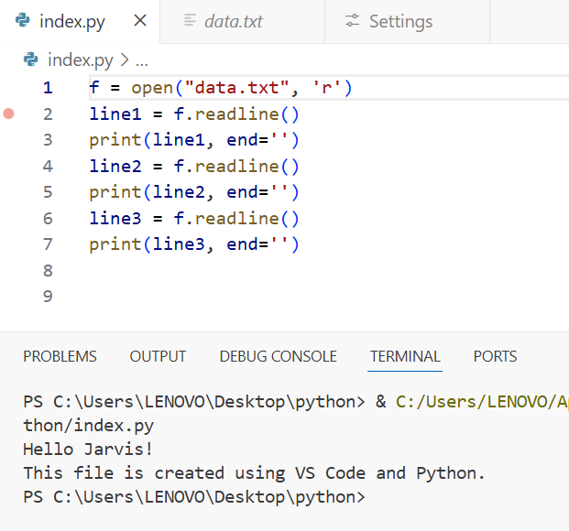

Example 4: To read all lines of a file into a list, you can use the readlines() method in Python. This method reads the entire file and returns a list where each element is a line from the file, including the newline characters.
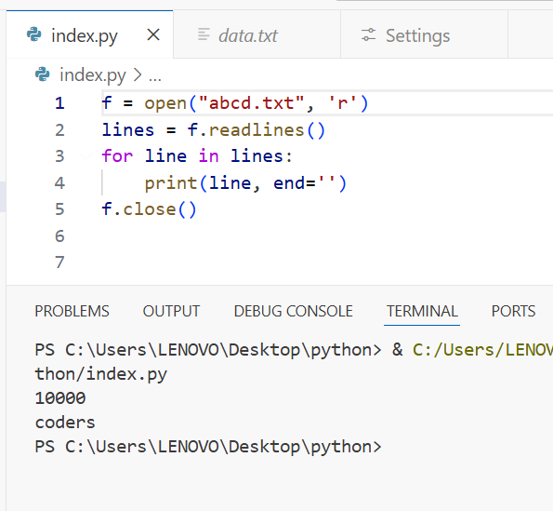

With Statement
The with statement lets you open a file and write all the code that works with the file inside a neat, indented block. The best part is, once your code finishes inside this block, Python takes care of closing the file for you automatically. This means you don’t have to worry about closing the file yourself, even if something goes wrong or an error happens while working with the file. This makes your code cleaner, safer, and easier to read.

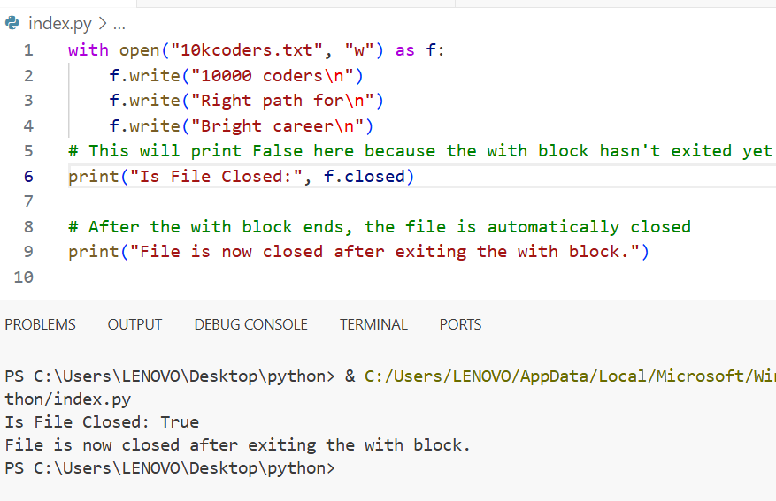
The seek() and tell() methods:
Tell()
The tell() method in Python is used to find out the current position of the cursor (also called the file pointer) inside an open file. Think of the cursor as a marker that shows where in the file you are right now—like a blinking caret in a text editor. The position starts at 0, which means the very beginning of the file, just like string indexing in Python where the first character is at position 0.
So, when you call tell(), it returns a number showing how many characters (or bytes) from the start of the file the cursor is currently pointing to. This is useful if you want to know where your next read or write will happen in the file.

Ex::
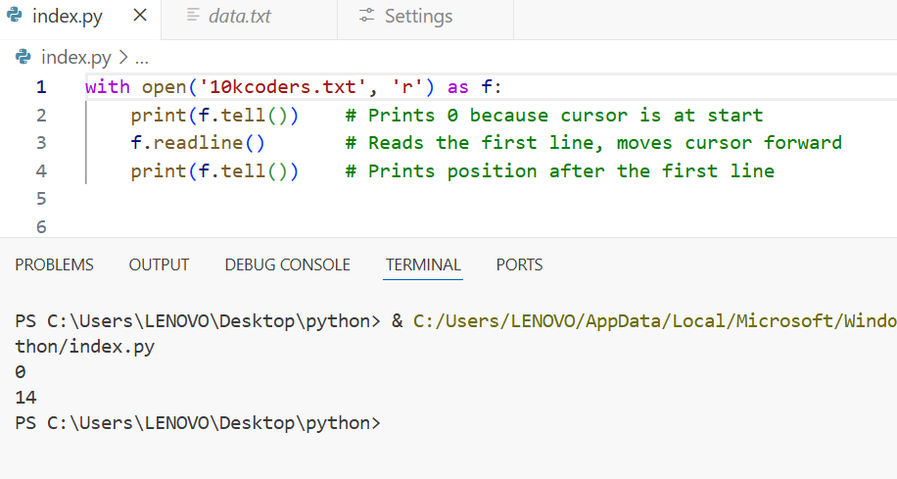
In this example, tell() helps you track where the cursor is inside the file, which can be handy when reading or writing file data step by step.
seek()
The seek() method allows you to move the cursor (also called the file pointer) to any position you want inside an open file. Imagine the file as a long scroll, and the cursor is your finger pointing to a specific spot. With seek(), you can jump to any place on that scroll to start reading or writing from there instead of going through the file step by step.
For example, if you want to skip the first 10 characters and start reading from the 11th character, you just tell Python to "seek to position 10," and the cursor will move there.
f.seek(offset, fromwhere)
offset represents the number of positions
The allowed values for second attribute(from where) are
0----From beginning of file(default value)
1----From current position
2----From end of the file

Note: Python 2 supports all 3 values but Python 3 supports only zero.
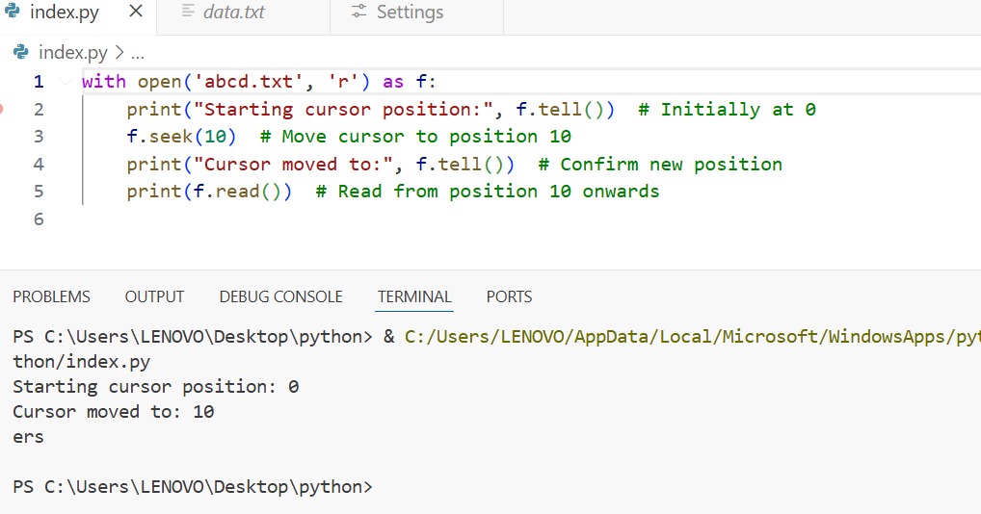

So, seek() is very useful when you need to read or write data from specific parts of a file quickly without reading everything before it. It moves the cursor exactly where you want it.
Note: The position count starts at zero, just like with string indexing, meaning the first character in the file is position 0.

This code demonstrates how you can read, move the cursor, and write to a file at any specific position using seek() and tell() in combination with read and write operations in Python.
Explanation for the below code :
- The file initially contains the text "All Students are STUPIDS".
- After reading the file fully, the cursor is at the end (position after the last character).
- Then the cursor is moved to the 17th position (counting from zero).
- The word "GEMS!!!" overwrites part of the text starting at that position.
- Finally, the whole content is re-read and printed, showing the updated text with "STUPIDS" partially or fully replaced by "GEMS!!!".

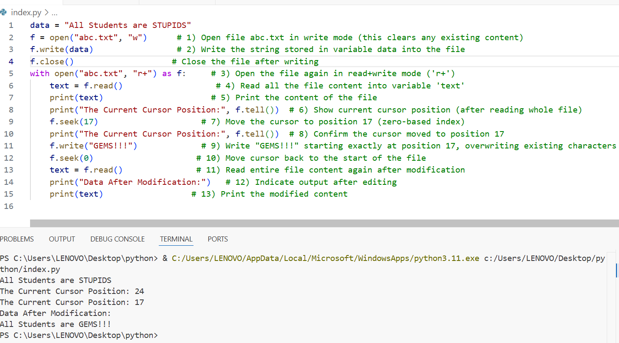

How to check a particular file exists or not?

To check whether a specific file exists on your computer, you can use Python’s built-in os module, which provides tools to interact with the operating system and its files. Inside the os module,
there is a submodule called os.path that contains useful functions for working with file paths.

One such function is os.path.isfile(). You pass the file name or file path to this function, and it returns True
if the file exists and is indeed a regular file. If the file does not exist or the path points to a directory
instead of a file, it returns False.

The position of the first character in a file is treated like an index starting from zero, so checking with this function ensures you’re dealing with a real file before reading or writing it.

Q1. Write a program to check whether the given file exists or not. If it is available then print its content?

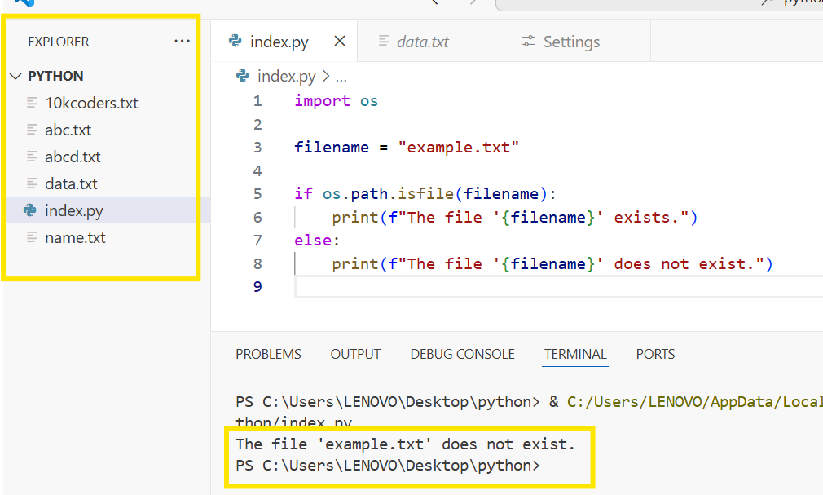

This will tell you clearly whether the specified file is present or not, making file handling safer and more reliable.
Q. Program to print the number of lines,words and characters present in the given file?

Explanation:
- The file is opened in read mode.
- For each line, the program increments the line count.
- It splits the line into words using the default whitespace separator and adds the count to word count.
- It counts all characters including spaces and newline characters for the character count.
- Finally, it prints out all three counts.
This simple and effective program helps analyze file content size quickly

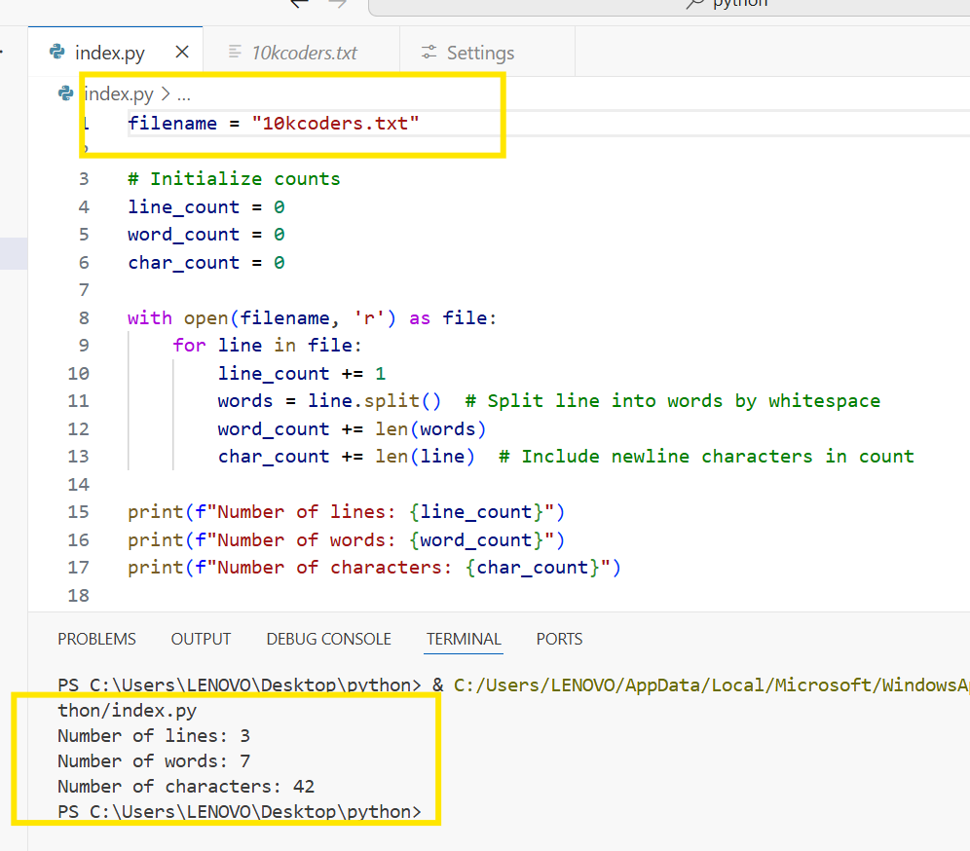
You can see the data in 10kcoders file
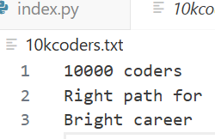

Handling Binary Data:
Handling binary data like images, videos, or audio files requires opening files in binary mode to read or write raw bytes.
Here is a simple Python program to read an image file and write its content to a new image file:
Explanation:
- 'rb' mode opens the file for reading in binary format.
- 'wb' mode opens the new file for writing in binary format.
- This program reads all binary data from the source image and writes it unchanged into a new file, effectively creating a copy.
- This method works for any binary file like images, videos, or audio.
Q. Program to read image file and write to a new image file?

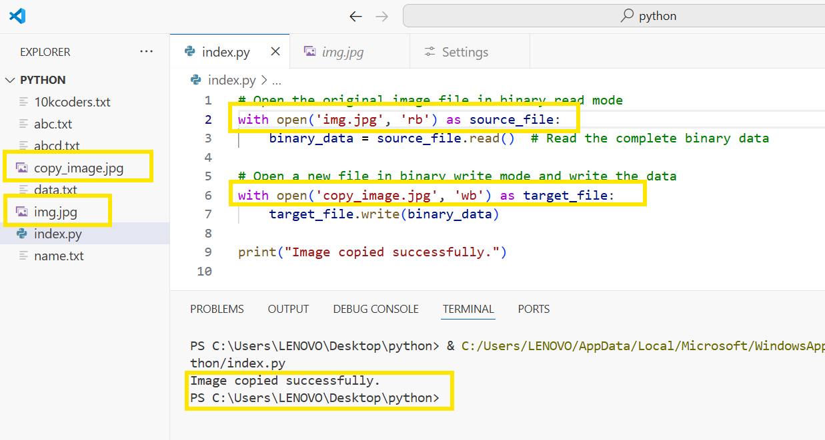

Handling csv files:
CSV==>Comma seperated values
As the part of programming,it is very common requirement to write and read data wrt csv files. Python provides csv module to handle csv files.

CSV (Comma Separated Values) files are widely used for storing tabular data such as spreadsheets and databases in plain text format where each line contains data fields separated by commas.
Python provides a built-in csv module to easily read, write, and manipulate CSV files.
Reading CSV Files
You can read CSV files using the csv.reader() function. This reads the file line by line, splitting each line by commas into a list of values.
Writing data to csv file:
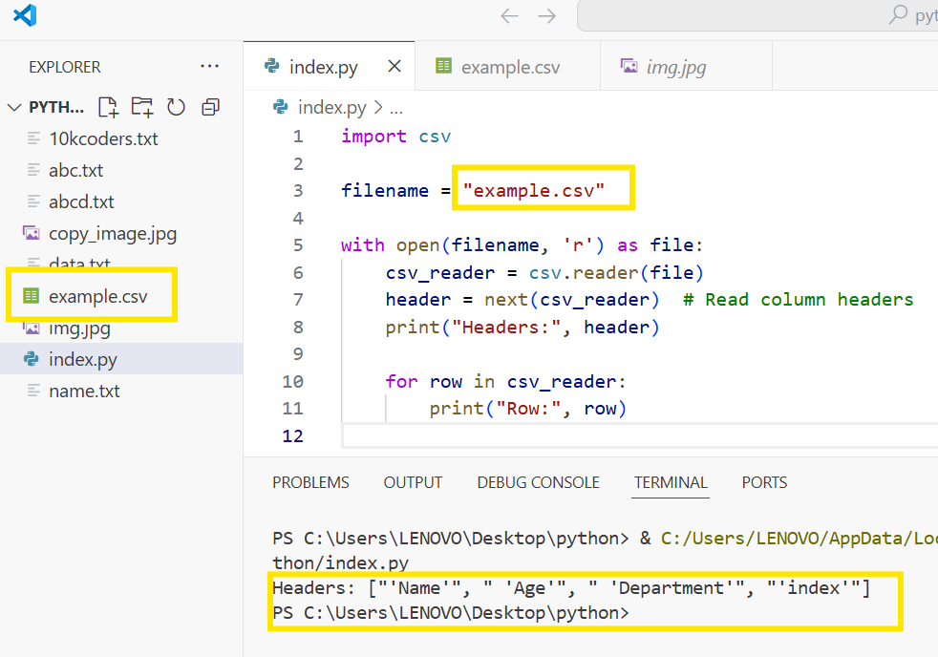

Note: If we are not using newline attribute then in the csv file blank lines will be included between data. To prevent these blank lines, newline attribute is required in Python-3,but in Python-2 just we can specify mode as 'wb' and we are not required to use newline attribute.

Zipping and Unzipping Files:
Why Zip Files?
Zipping files compresses them into a single smaller package, which helps save disk space, speeds up file transfer, and improves overall performance when handling multiple files.
Python's zipfile Module
Python offers the zipfile module that allows easy create, read, write, and extract operations on ZIP files.
Creating a Zip File
To create a ZIP file, you use the ZipFile class. You create an instance by giving the zip file's name, the mode ('w' for write), and a compression constant called ZIP_DEFLATED which tells Python to compress the files.
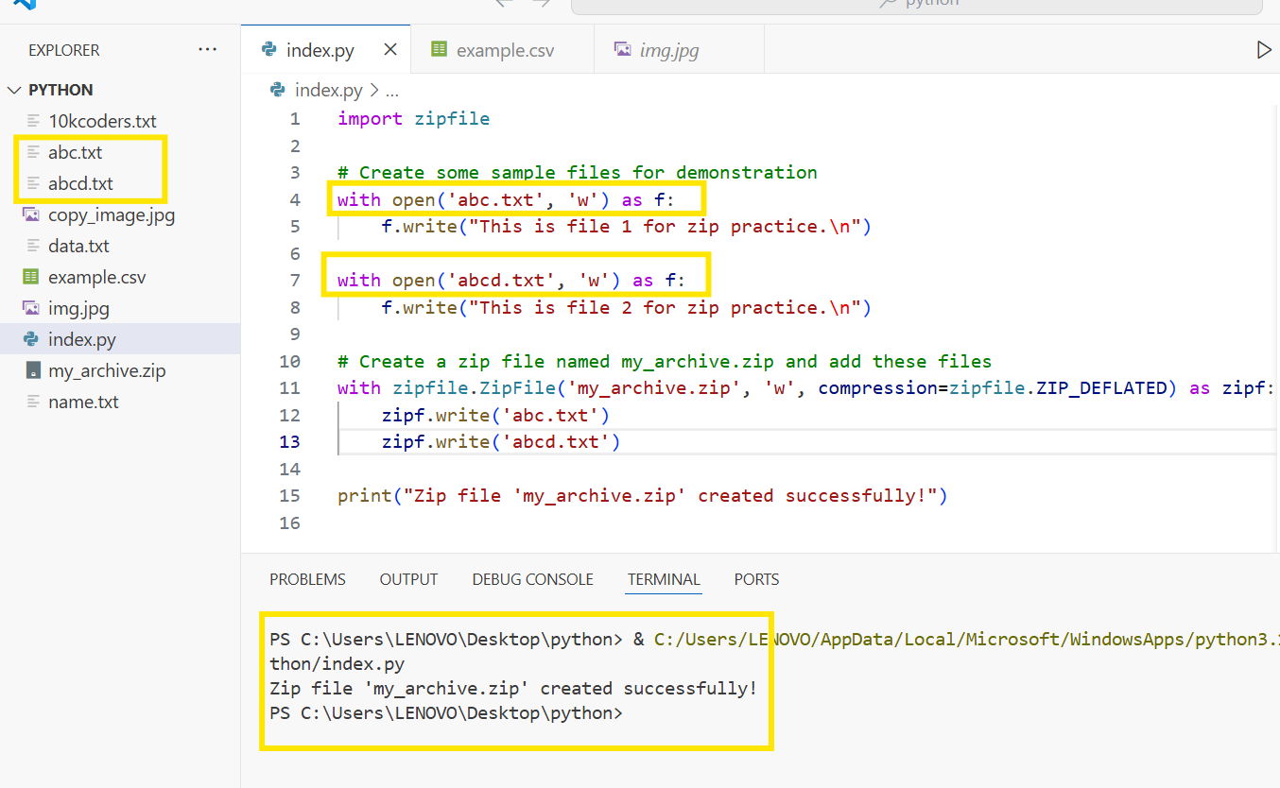

- Running this script will create two text files, add them to my_archive.zip, and save it in your current directory.
- You can then practice reading or extracting this zip file using Python or any zip software.
It is very common requirement to zip and unzip files.
The main advantages are:
1. To improve memory utilization
2. We can reduce transport time
3. We can improve performance.
To perform zip and unzip operations, Python contains one in-bulit module zip file.
This module contains a class : ZipFile
To create Zip file:
We have to create ZipFile class object with name of the zip file,mode and constant ZIP_DEFLATED.
This constant represents we are creating zip file.
f = ZipFile("files.zip","w","ZIP_DEFLATED")
Once we create ZipFile object,we can add files by using write() method.
f.write(filename)

To perform unzip operation:
To perform unzip (extract) operations in Python using the zipfile module, follow these steps:
- Import the zipfile module.
- Create a ZipFile object by opening the existing zip file in read mode ('r').
- Use the extractall() method to extract all files from the zip archive to a target directory.
- Close the ZipFile object automatically using a with statement.
Here is an example code snippet:
We have to create ZipFile object as follows
f = ZipFile("files.zip","r",ZIP_STORED)
ZIP_STORED represents unzip operation. This is default value and hence we are not required to specify.
Once we created ZipFile object for unzip operation,we can get all file names present in that zip file by using namelist() method.
names = f.namelist()

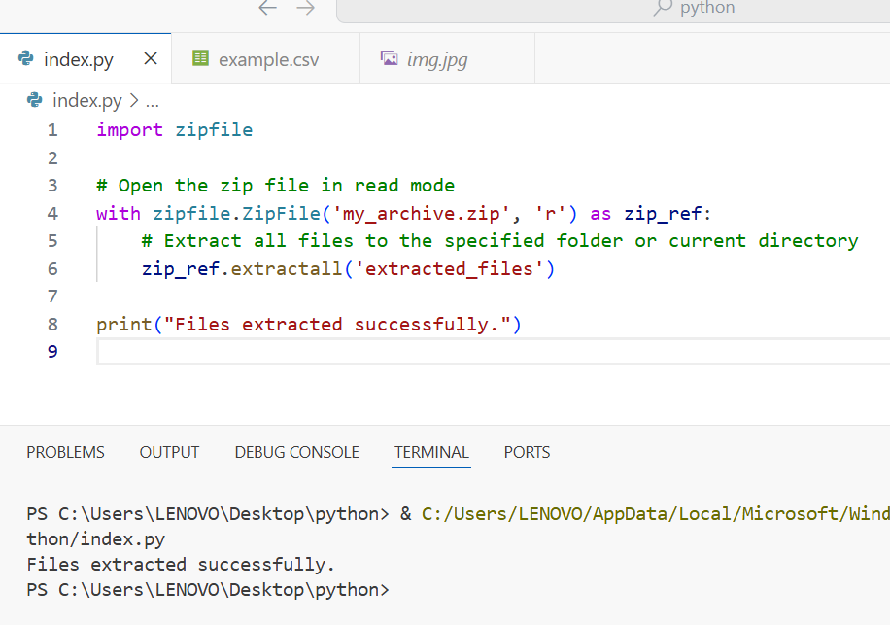

Working with Directories:
It is very common requirement to perform operations for directories like
1. To know current working directory
2. To create a new directory
3. To remove an existing directory
4. To rename a directory
5. To list contents of the directory
To perform these operations,Python provides inbuilt module os,which contains several functions to perform directory related operations.

To know the current working directory in Python, you can use the os module's getcwd() method. It returns the path of the directory where your Python program is currently running.

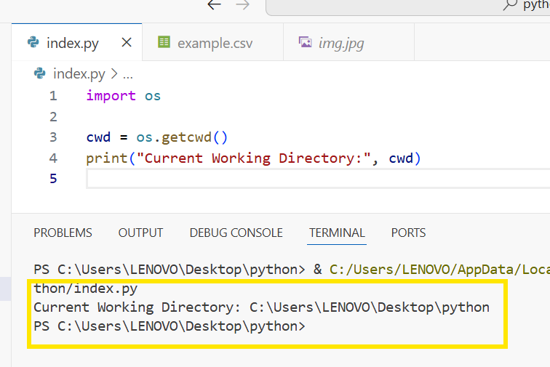
- os.getcwd() fetches the current directory path as a string.
- This directory is where Python looks for files if you open them without specifying a full path.
- It helps you understand the context your program is working in, especially when dealing with file operations.
This method is commonly used and very handy for debugging and file management tasks in Python programs.
Q2. To create a sub directory in the current working directory:
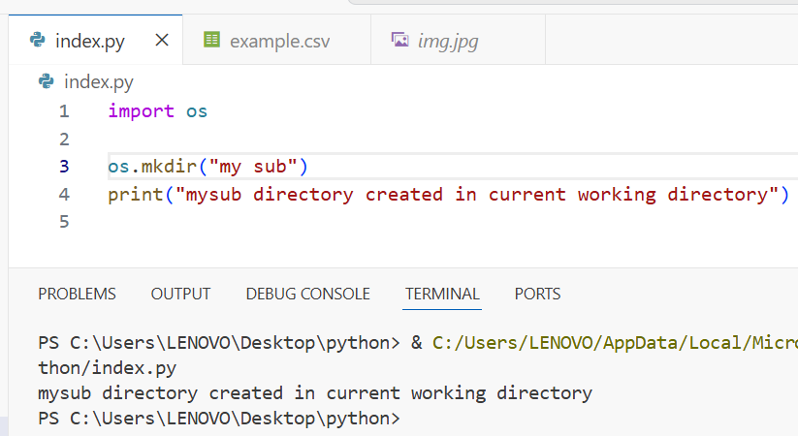
- os.mkdir("mysub") creates a new directory named mysub inside the folder where your Python script is running (the current working directory).

- If the directory already exists, Python will raise a FileExistsError.
- After the directory is created, the program prints a confirmation message.
If you want to create nested directories (subdirectories inside multiple layers), you should use os.makedirs() instead, which can create all intermediate directories automatically.
This method is simple and commonly used for directory management in Python programs.

Q3. To create a sub directory in mysub directory:
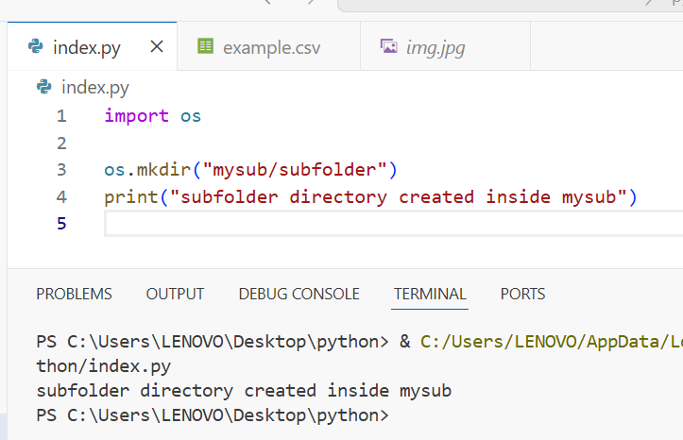
Explanation:
- "mysub/subfolder" specifies the path where the new directory will be created.
- The mysub directory must already exist, or else this will raise a FileNotFoundError.
- Use this approach to organize folders hierarchically by creating subdirectories inside parent directories.
Alternatively, if the parent directory might not exist and you want to create all intermediate directories, you can use os.makedirs("mysub/subfolder") which automatically creates all missing intermediate folders.
This is the typical way to create nested directories in Python.
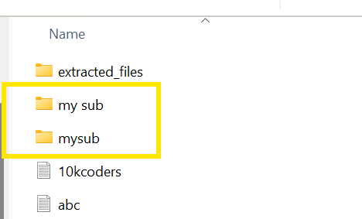

u can see what we created in local system
Q4. To create multiple directories like sub1 in that sub2 in that sub3:
import os
os.makedirs("sub1/sub2/sub3")
print("sub1 and in that sub2 and in that sub3 directories created")

Q5. To remove a directory:
import os
os.rmdir("mysub/mysub2")
print("mysub2 directory deleted")

Q6. To remove multiple directories in the path:
import os
os.removedirs("sub1/sub2/sub3")
print("All 3 directories sub1,sub2 and sub3 removed")

Q7. To rename a directory:
import os
os.rename("mysub","newdir")
print("mysub directory renamed to newdir")

Q8. To know contents of directory:
To know the contents of a directory in Python, you can use the os.listdir() function from the os module. This function returns a list of all files and directories inside the specified directory. If no directory is specified, it lists the contents of the current working directory.

Example to list all contents of the current directory:
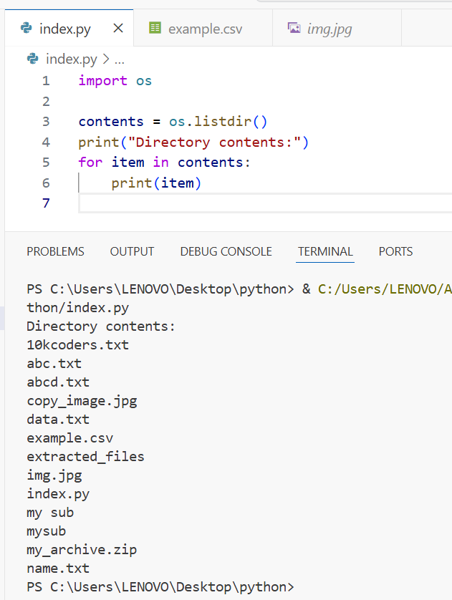
The above program display contents of current working directory but not contents of sub directories. If we want the contents of a directory including sub directories then we should go for walk() function.
Q9. To know contents of directory including sub directories:

To know the contents of a directory including all its subdirectories (i.e., recursively), Python provides several methods. The most common and efficient one uses the os.walk() function from the os module.
Using os.walk() to list directory contents recursively:

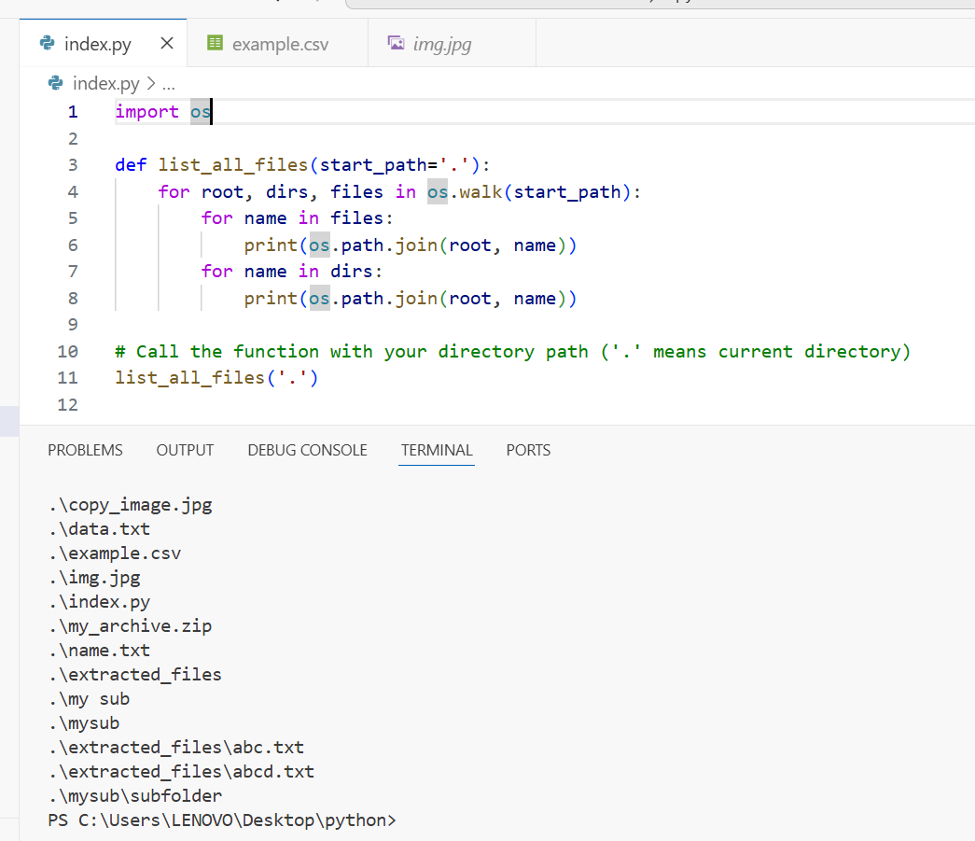
Explanation:
- os.walk(start_path) traverses the directory tree starting at start_path.
- It yields a tuple (root, dirs, files) for each directory it visits.
- root is the path to the current directory.
- dirs is a list of subdirectory names in root.
- files is a list of file names in root.
- os.path.join(root, name) creates full path names.
- This method prints the full paths of all files and directories under the specified path recursively.

The difference between os.listdir() and os.walk() functions in Python is:
Feature | os.listdir() | os.walk()
Purpose | Lists all files and directories in a single specified directory only. | Recursively walks through a directory tree, listing files and directories in all subdirectories as well.
Return type | Returns a list of names (strings) of files and folders in the specified directory. | Yields a tuple (root, dirs, files) for each directory in the tree, with full context of directory paths, subdirectories, and files.
Depth | Non-recursive, only the immediate contents of the directory. | Recursive, traverses entire directory tree starting at the given root.
Use case | When you just need to see what's inside one specific folder. | When you want to explore all files and subfolders in all nested directories.
Efficiency | Faster for listing a single directory. | More powerful but heavier, since it visits every subdirectory.
Additional features | Does not differentiate files or folders by metadata. You need extra code for that. | Uses os.scandir() internally (Python 3.5+) and provides separate lists of directories and files.

How to get information about a File:
We can get statistics of a file like size, last accessed time,last modified time etc by using stat() function of os module.
To get detailed information about a file such as size, last access time, last modification time, and more, Python provides the os.stat() function from the os module.
What os.stat() does:
- It performs a system call to retrieve metadata about the given file path.
- It returns an object containing attributes representing various file statistics.
Common attributes of the os.stat_result object:
- st_size: Size of the file in bytes.
- st_atime: Time of last access (in seconds since epoch).
- st_mtime: Time of last modification (in seconds since epoch).
- st_ctime: Time of metadata change (Unix) or creation time (Windows).
- st_mode: File type and permissions.

- st_uid: Owner user ID.
- st_gid: Owner group ID.
- st_nlink: Number of hard links.

Example code to get file information:
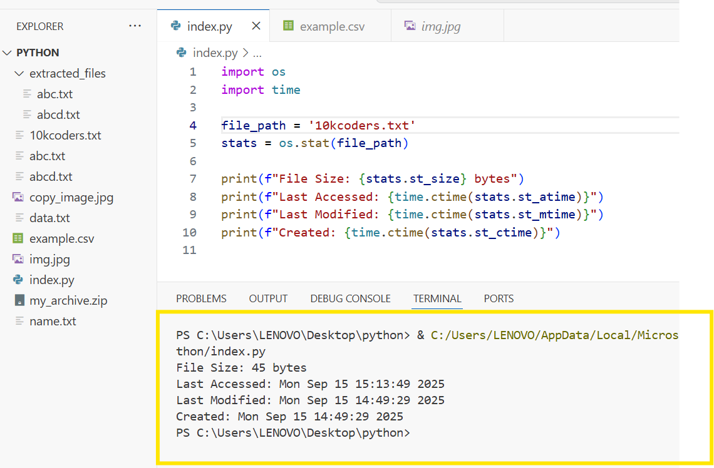
Explanation:
- os.stat(file_path) returns info about the file.
- time.ctime() converts the timestamp to readable date and time string.
- You can access detailed permissions and other metadata through other attributes if needed.
This method provides a comprehensive way to examine file properties in Python programs for monitoring, logging, or conditional processing

Pickling and Unpickling of Objects:
Pickling and unpickling in Python refer to the process of saving and loading the entire state of a Python object to
and from a file, respectively. This is useful when you want to persist complex objects like custom classes, dictionaries, lists, etc., so they can be stored and retrieved later without losing their state.
Pickling (Saving an object to a file)
The pickle module’s dump() function saves an object’s state into a file in a binary format.
Unpickling (Loading an object from a file)
The pickle module’s load() function reads the saved file and reconstructs the object in memory.
Example of Pickling and Unpickling with pickle module:
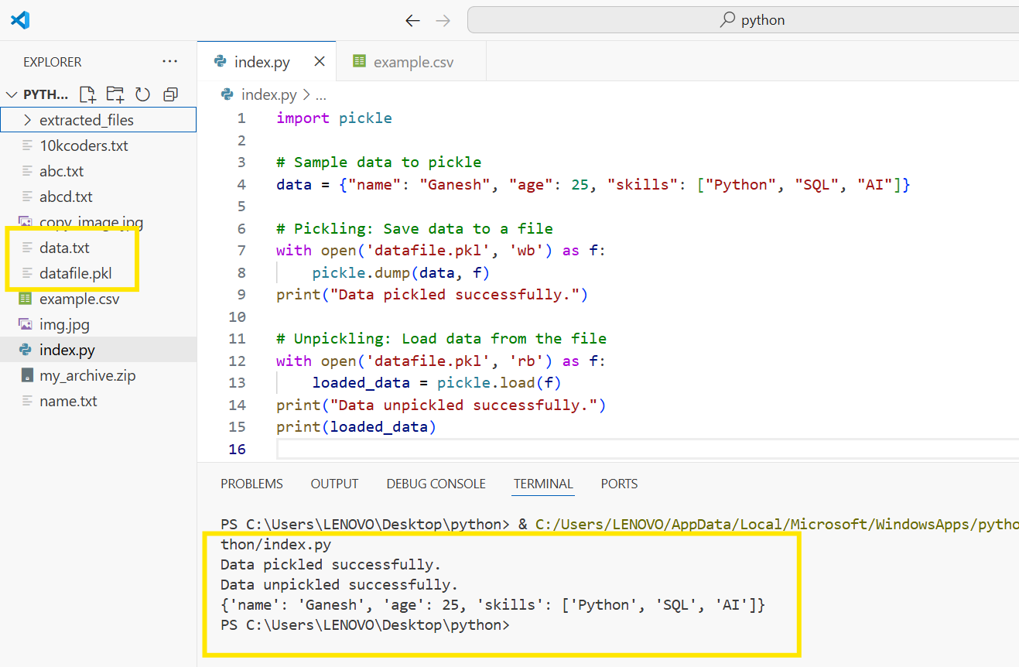
Explanation:
- 'wb' mode in open means write binary for pickling.
- 'rb' mode means read binary for unpickling.

- pickle.dump(obj, file) writes the object obj to the file.
- pickle.load(file) reads from the file and reconstructs the object.
This allows you to save the complete Python object and retrieve it later exactly as it was, including nested structures and custom objects, making it excellent for data persistence and caching in Python programs.

Here is a simple conceptual image describing the process of pickling and unpickling in Python:
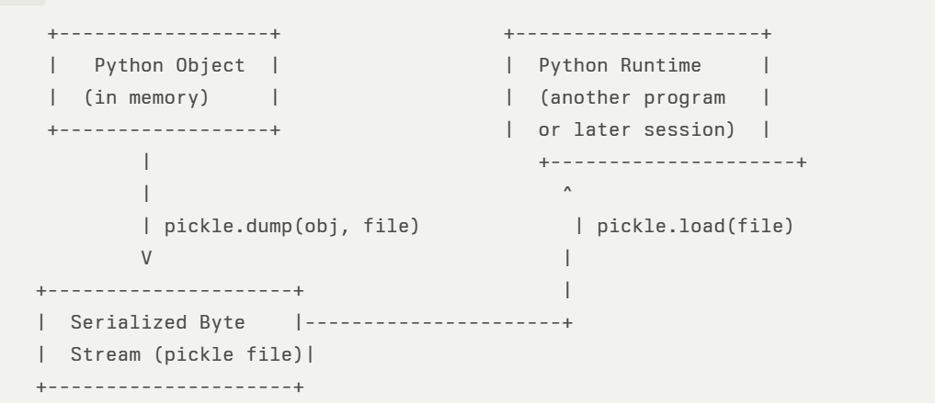
- Pickling: Converts a Python object (with its entire structure and data) into a serialized byte stream and saves it to a file using pickle.dump().
- Unpickling: Reads the serialized file and reconstructs the original Python object in memory using pickle.load().

Writing and Reading State of object by using pickle Module:
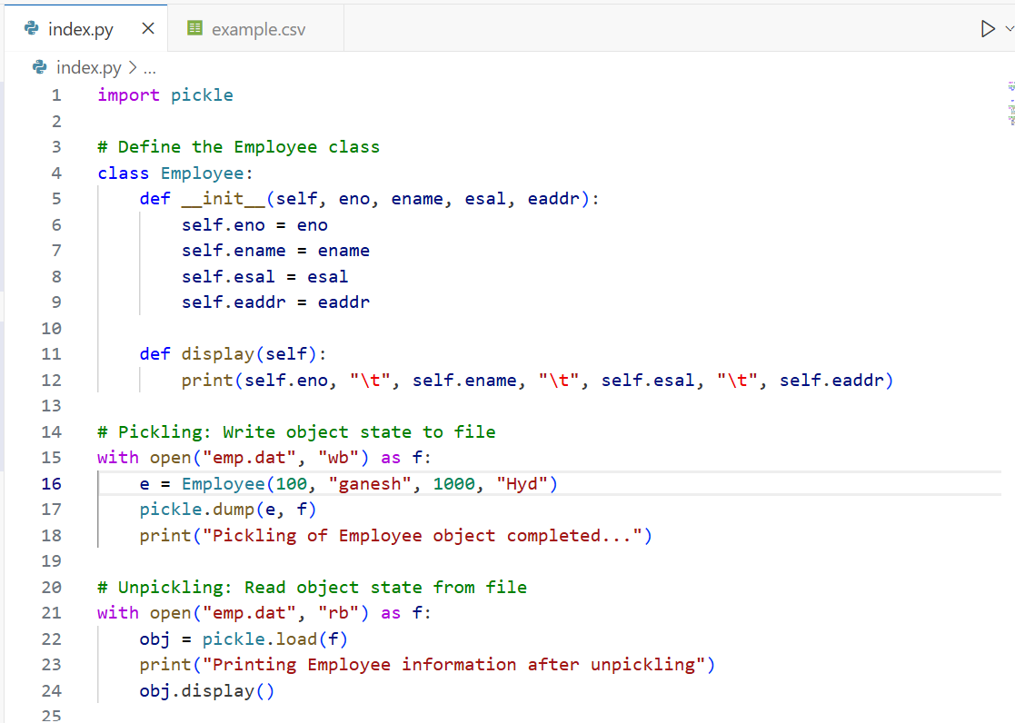
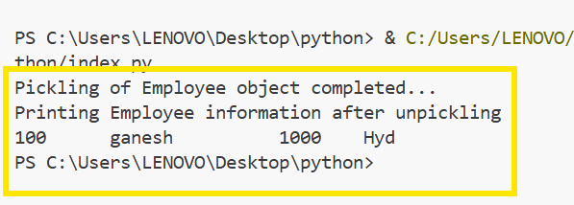
Explanation:
- The Employee class has attributes and a method display for printing its data.
- When you pickle the Employee object e using pickle.dump(), its state (all attribute values) is saved to the binary file emp.dat.

- Later, you can unpickle the object using pickle.load() to read the saved data back into an equivalent Python object with the same attribute values.
- The display() method shows the object's details after unpickling, proving the state was preserved.
Writing Multiple Employee Objects to the file:
To write multiple Employee objects to a file using the pickle module, you can store them all in a list and then pickle the entire list at once. Later, you can unpickle that list and access each Employee object.
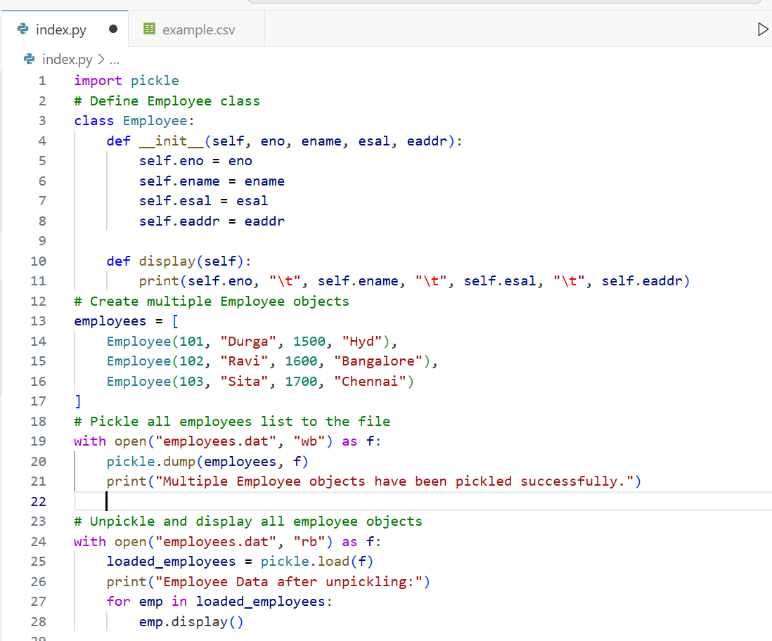

Out put:;
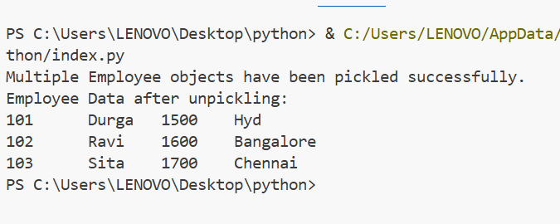

The provided pick.py code snippet is designed to create multiple Employee objects by taking user input and then pickle (serialize) each object one by one into a file named emp.dat.
To conclude file handling notes effectively, consider adding these points:
- Always close files after opening them to free system resources, or use with statement which automatically handles closing.
- Handle exceptions such as FileNotFoundError or IOError to make programs robust.
- Understand the difference between reading/writing text ('r', 'w') and binary modes ('rb', 'wb') based on file type.
- For complex data persistence, use serialization modules like pickle.
- Use file and directory management modules (os, shutil, zipfile) for advanced operations.
- Always be cautious with file paths and working directories to avoid errors.
- Remember security considerations when dealing with file input/output, especially with untrusted data.
These points will round up your notes with practical best practices and important cautions

